Directorate General FOR Internal Policies
Policy Department a: ECONOMIC AND SCIENTIFIC PolicY

Recent ECB Actions

IN-DEPTH ANALYSIS

Abstract
With the inflation rate edging down away from the comfort zone, the ECB has announced new measures. The reduction of the policy interest rates is mostly symbolic. More substantial are the decisions to inject liquidity into the banking system. These measures are designed to bring to an end and reverse the downward trend of bank loans, as well as to reduce financial fragmentation in the Eurozone. However the ECB’s brand of quantitative easing is less decisive than those adopted in other major central banks because the initiative is now in camp of banks and financial institutions. They may, or not, oblige. Another concern is that these measures assume that bank lending is hampered by a lack of liquidity, which may not be case.

IP/A/ECON/2014-03 September 2014
Part of the compilation PE 536.284 for the Monetary Dialogue EN
This document was requested by the European Parliament's Committee on Economic and Monetary Affairs.

AUTHOR

Charles WYPLOSZ, Graduate Institute of International and Development Studies, Geneva

RESPONSIBLE ADMINISTRATOR

Dario PATERNOSTER
Policy Department A: Economic and Scientific Policy
European Parliament
B-1047 Brussels
E-mail: Poldep-Economy-Science@europarl.europa.eu

LINGUISTIC VERSIONS

Original: EN

ABOUT THE EDITOR

Policy departments provide in-house and external expertise to support EP committees and other parliamentary bodies in shaping legislation and exercising democratic scrutiny over EU internal policies.

To contact the Policy Department or to subscribe to its monthly newsletter please write to:
Poldep-Economy-Science@europarl.europa.eu

Manuscript completed in September 2014.
© European Union, 2014.

This document is available on the Internet at:
http://www.ep.europa.eu/studies

DISCLAIMER

The opinions expressed in this document are the sole responsibility of the author and do not necessarily represent the official position of the European Parliament.

Reproduction and translation for non-commercial purposes are authorised, provided the source is acknowledged and the publisher is given prior notice and sent a copy.

CONTENTS
EXECUTIVE SUMMARY 4
1. INTRODUCTION: Rationale for ecb action 5
2. OBJECTIVES 7
2.1. Achieving a self-sustained recovery 7
2.2. Weakening the exchange rate 8
2.3. Keeping inflation expectations anchored 9
3. NEGATIVE INTEREST RATE 10
4. BOND PURCHASES 12
4.1. Targeted Long Term Refinancing Operations (TLTRO) 12
4.2. Asset Backed Securities and Covered Bonds Purchases 12
5. THE DIFFERENCE WITH QE 14
6. CONCLUSION 15
REFERENCES 16

EXECUTIVE SUMMARY
Between June and September 2014, the ECB has announced a series of measures designed to deal with an inflation rate significantly below its own definition of price stability. Three measures have been taken:
- A reduction of the policy interest rates.
- A new programme to provide liquidity to banks on the basis of their loans to the private sector, excluding housing loans.
- A programme focused on housing loans.
The interest rate action is symbolic, being too small to have any significant impact.
The new Targeted Long-term Refinancing Operation is an encouragement to commercial banks to increase their lending activity. This makes sense as the value of loans outstanding has declined over the last two years. It will take the form of loans to commercial banks, due to mature in September 2018. The amounts available to each bank will depend on the size of its portfolio for the first wave of September and December 2014. A second wave, due to start in March 2015 and conclude in June 2016, will take into account new loans to the private sector.
The last programme aims at housing loans. The ECB stands to buy portfolios of loans put together as Asset Backed Securities and covered bonds. The ABS will be tranched into parts ranked by seniority and the ECB will buy the safer tranches. This programme will require a revival of ABS activity, in spite of the tarnished reputation of these instruments following the US subprime crisis.
In contrast with now-standard Quantitative Easing (QE) programmes, the ECB has not announced any amount of liquidity injection. It cannot. Indeed, standard QE involves purchases of existing assets, mostly public debt instruments. In that case, the central bank can decide what it buys, when and how much of it. The ECB programmes depend entirely on how much commercial banks will wish to offer. The overall effect is therefore unknown and subject to the following doubts:
- The programmes assume that sluggish lending activity is due to a lack of liquidity in the banking system. As the system is fragmented, liquidity is not widely shared and the programme should improve the situation in that respect. Overall however, evidence does not support the view that lending activity is restrained by banks’ ability to lend. Weak demand for loans is the most likely reason, in which case the programme aims at the wrong end of the market.
- ABS are risky instruments because their components, individual loans, cannot really be traced back and assessed. Some of the risk will be transferred to the ECB.
- The possibility of banks to sell loans may encourage banks to take more risks, a feature less marked with covered bonds.
In the end, non-economic considerations explain both the lateness of the ECB decisions and the particular shape of the programmes.

INTRODUCTION: Rationale for ecb action
The Eurozone recovery is proving to be weak, weaker than predicted earlier by the ECB or the European Commission. Along with a strong euro, this has led to a significant decline in the rate of inflation, way below the ECB’s definition of price stability. Given that monetary policy actions take about one year to develop their effects, first on growth, next on inflation, today’s situation is the result of inaction one year ago and ever since. The announcements of June and September 2014 are designed to make up for time lost.
In both cases, the ECB lowered its interest rates and indicated its intention to provide more liquidity to banks and financial markets. Figure 1 displays the three policy rates since 1999, along with the interbank overnight rate EONIA. Until the early 2009, the EONIA rate was entirely driven by the main refinancing rate, as intended by the ECB. Since then, the interbank rate has followed instead the lower policy rate, the deposit rate. The main reason is that the ECB has provided banks with very large amounts of liquidity, in response to the crisis situation. Extremely concerned by funding conditions, banks were eager to build up cash buffers, which they largely deposited with the ECB. Deposits at the ECB have therefore become the default option. Even though the EONIA rate has lost some of its significance as the interbank market has broken down in line with the fragmentation of financial markets within the Eurozone, the fact is that the effective cost of money for banks in the core countries has fallen to close to 0% since late 2011.

Figure 1: ECB interest rates (January 1999 - September 2014)
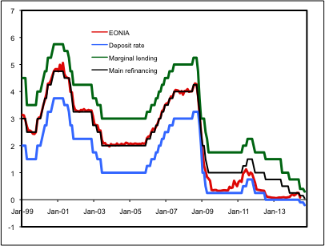

Source: ECB

Like other major central banks, the ECB finds itself caught at the zero lower bound with the need to pursue an expansionary policy. The solution adopted elsewhere (USA, UK, Japan) consisted of large injections of liquidity. The ECB already went into this direction with previous programmes (Securities Markets Programme (SMP), Covered Bond Purchase Programmes (CBPP), Long Term Refinancing Operations (LTRO)) but for relatively small amounts and sometime even sterilized these interventions to prevent an increase in liquidity.
Quantitative easing (QE), as these liquidity creating programmes are called, has taken diverse forms in various countries and over time. The common feature is an ex ante commitment to create a pre-set volume of liquidity over a given horizon (e.g. per month) through asset purchases. While the bulk of these purchases concerned public bonds, specific private securities have been targeted in the US and in the UK. In addition, the Bank of England ran a special programme, Funding for Lending, that involved lending to financial institutions in relation to their loan activity, and even lending to non-banks that offer loans to SMEs (Small and Medium Enterprises).
There is some debate over the effectiveness of QE. Research at the Federal Reserve reports that QE has had a material effect on the economy (Christensen and Rudebusch, 2012). Independent research reports that QE has lowered borrowing costs (Krishnamurthy and Vissing-Jorgensen, 2011). Similar results are available for the UK (Kapetanios et al. 2012), with additional informal evidence suggesting that the Funding for Lending scheme is playing a role in the recovery. A review of both experiments is Baumeister and Benati (2013).
The ECB response combines a lowering of its interest rates and three programmes: Targeted Long Term Refinancing Operations (TLTRO), purchases of Asset Backed Securities (ABS) and of covered bonds. Section 2 looks at the interest rate decision, Section 3 examines the liquidity programmes. The difference between the ECB programmes and QE elsewhere is developed in Section 5. Section 4 offers some conclusions.

OBJECTIVES
With inflation significant below the “close to but below 2%” objective, the ECB is effectively obligated to push it up. Inflation is driven by three main factors:
- The activity level
- The exchange rate
- Inflation expectations.
The question is how the ECB can influence these factors.

Achieving a self-sustained recovery
A strong regularity, which goes not under name of Phillips curve, is that strong growth leads to declining unemployment and tighter labour market conditions. This then encourages faster wage growth. Facing rising labour costs, firms raise prices faster. Obviously, the process goes in reverse in the event of a recession, as we see since 2012.
The main channel of monetary policy is lending to the private sector. Under normal circumstances, this is done by lowering the interest rate to encourage demand for loans by households and firms, but circumstances are not normal. With the interest rates at zero or less, QE aims at encouraging banks and other lenders (insurance companies, investment funds) to expand loans. The idea is that abundant liquidity should lead to easier lending conditions, such as relaxing terms of payments and eligibility criteria.
Lending, indeed, is underperforming. Figure 2 displays the total value of loans outstanding to the private sector. The first observation is that, normally, the stock of loans keeps increasing as banks lend more than they recover from past maturing loans. The steepening of the curve around 2005 reflects the excesses that contributed to the crisis. The second observation is that, since early 2008, the stock of loans has remained almost unchanged and that it has been declining since 2012 after a timid recovery in 2010. For nearly three years now, net lending is negative. Reversing this trend is the objective clearly stated by the ECB.
The strategy is to kick-start a wave of positive net lending. More loans should revive consumer spending and corporate investment. This, in turn, would lead to more activity, more incomes and therefore more spending, partly financed by more loans. The recovery would occur and feed into itself.
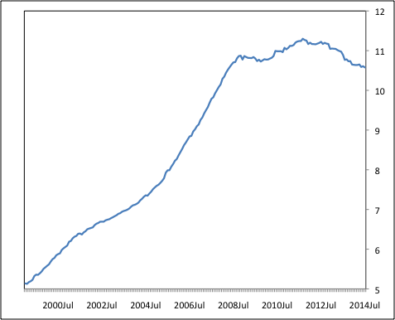
Figure 2: Loans outstanding to the non-financial private sector (trillion euros)

Source: ECB

Weakening the exchange rate
A weaker exchange rate means that the prices of imported goods rise. Some of these are consumer goods, and the increases directly affect the cost of living. Others are intermediate goods; higher production costs soon translate into faster rising prices for domestic production. Some goods are used for both purposes. A depreciation is one of the surest ways of fuelling inflation.
One of the surprises of the sovereign debt crisis is that the euro has remained rather strong. Figure 3 displays the average of the value of the euro relatively to a large sample of countries, the effective exchange rate. Although it did decline from the high, overvalued level reached in late 2009, it grew again after President Draghi’s “whatever it takes” declaration of July 2012.

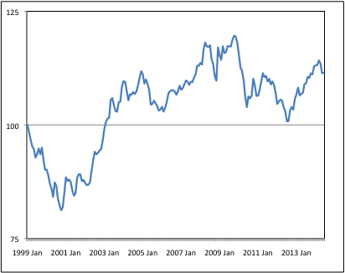
Figure 3: Effective exchange rate (January 1999 = 100)

Source: International Financial Statistics, IMF.
A possible reason is that the ECB has been rather less active than the other major central banks, in particular in its support of the level of activity (Wyplosz, 2011). As can be seen in Figure 1, it even started to tighten its policy stance in mid-2011, in sharp contrast with expansionary efforts elsewhere. The ECB always reminds us that it has no exchange rate policy, which is indeed an implication of its strategy of setting the interest rate according to its price stability mandate. Yet, it admits that the exchange rate is one of the factors affecting inflation, which means that it is looked at and taken into account.
Indeed, over the recent months, the ECB has repeatedly signalled that it views the euro as too strong, implying that it would like to see it depreciate. Talking the euro down has proven to be insufficient, however. A more forceful action, along the lines announced recently, is likely to make a lasting difference. Injecting vast amounts of liquidity increases the supply of euros worldwide and is bound to lower the value of the euro.

Keeping inflation expectations anchored
Anticipations of future inflation affect wage and price settlements as well as financial market pricing of assets. The latter concerns interest rates, a key channel of monetary policy. This is why the ECB, and all other central banks, are so eager to keep inflation expectations anchored close to their targets.
Figure 4 reports market expectations, as collected by the ECB. The latest observations fall in the range “below but close 2%”, which indicates that fears of disinflation are not widespread. The continuous decline is in fact welcome. So far, at least, expectations are well anchored.

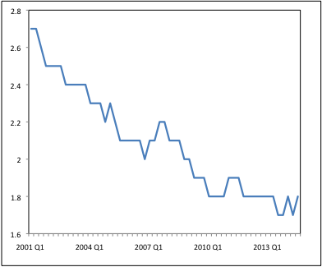
Figure 4: Inflation expectations five-year ahead

Source: Survey of Professional Forecasters, ECB

NEGATIVE INTEREST RATE
As seen from Figure 1, the ECB has brought its lower policy interest rate into negative territory in two steps: -0.1% in June and -0.2% in September. Requiring that banks pay to hold excess reserves at the ECB is symbolically striking. Yet, as the figure shows, these are very small steps. It would be surprising that they would have a significant effect.
The idea is to encourage banks to use their amounts of excess reserves to lend to the private sector. This begs the question of why they do not lend.
The reasoning behind the ECB actions aims at reinvigorating the supply of credit, in a context where banks are engaged in deleveraging. It remains to be seen whether the poor lending performance is driven by supply or by demand factors. Negative net credit growth may well lead to poor economic growth, but poor economic growth can lie at the roots of weak demand for credit.
Disentangling demand and supply is technically complex and there does not seem to exist work dealing directly with this question in the Eurozone at the present juncture. In its Bank Lending Survey the ECB interprets answers to identify “net demand” (the difference between banks reporting increases and banks reporting decreases in loans) but that is not really measuring demand. Indirect evidence is that demand is and remains week. Indeed, according to the same survey, lending conditions have been declining since mid-2013, a sign that supply is growing easier. Yet, Figure 2 shows that total credit outstanding has declined, which suggests that demand is the constraining factor.
If this is the correct diagnosis, lowering the policy interest rate can have an effect if two conditions are satisfied:
- the effect is transmitted to ultimate borrowers;
- the reduction is large enough to raise demand.
None of these conditions is satisfied. Despite large reductions in country-specific spreads, national credit markets remain fragmented. As Figure 1 makes clear, the recent interest rate cuts are essentially symbolic. In fact, the main change in the cost of credit comes from the reduction of risk premia on sovereign debts following the OMT programme. This can be seen from Figure 5, which displays the ECB refinancing rate along with the highest and the lowest national average interest rates charged by banks to households for house loans. The figure confirms the opening of a large gap across countries starting in 2009. The gap has declined somewhat after the adoption of the OMT programme, but much less than the reduction on risk premia on sovereign bonds. This confirms that the Eurozone remains financially fragmented. Another important observation is that, once it has moved close to the zero lower bound, the policy rate has stopped to exert a clear influence on the interest rates charged by banks to private customers. Loans to private corporations provide a very similar picture. Clearly, the latest policy changes will not help restart bank lending to the private sector.

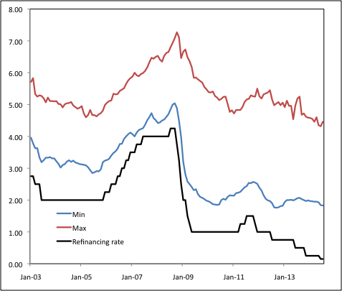
Figure 5: Interest rates on house loans within the Eurozone

Note: Maximum and minimum interest rates across Eurozone countries.
Source: ECB

BOND PURCHASES
Given how little difference the interest rate decisions can make, the ECB has announced two additional non-standard actions. They are analysed below.

Targeted Long Term Refinancing Operations (TLTRO)
LTROs are not new. During the crisis, the ECB has gradually extended its loans from the very short term to three years. The intent, then, was to reduce fragmentation and to stabilize funding for banks badly hurt by the crisis, especially those in the worst hit countries. The new programme fits into the general objective of restarting lending activity. Loans are offered to banks in proportion to their own lending to the private sector, housing loans being excluded. In the first wave, to occur in September and December 2014, banks may borrow from the ECB up to 7% of their loan portfolio as of April 2014. In the second wave, to take place quarterly between March 2015 and June 2016, they will be able to borrow up to three times the amounts that they will have lent since April 2014. All loans are due to mature in September 2018.
As previous LTROs, the new ones are likely to attract banks from the periphery that face large borrowing costs, hence reducing fragmentation. The targeting part, directly linking the programme to bank lending activity, well fits the objectives. Various safeguards are introduced to prevent abuse of the system by banks that do not increase lending to the corporate private sector. On the other hand, the programme faces four main limitations:
- The existing stock of lending, the basis of the first wave allocations, is large in the large non-crisis countries. This will not help much with fragmentation. The second wave, however, is a clear encouragement to lend, independently of the starting position and stands to benefit banks most interested. It remains to be seen whether this programme will affect most the crisis countries.
- The provisions against participating in the programme and yet not raise lending are weak. Banks that do not increase lending can still hold the borrowed funds for two years and use them for various potentially profitable carry trade operations, including acquiring public bonds or assets issued outside the Eurozone.
- Banks in need of cheap funding may be tempted to make risky loans. “Gambling for resurrection” is a classic step towards bank fragility. The ECB will take some counter-party risk if the collateral is weak.
- The most crucial limitation is that the programme assumes that bank lending is held back by a lack of liquidity. As noted above, there is little evidence that it is the supply of loans that prevents bank-lending growth.

Asset Backed Securities and Covered Bonds Purchases
It is not clear why the TLTRO excludes housing loans. The likely explanation is that encouraging this form of lending is the purpose of the programme announced in September. The programme includes outright purchases of portfolios of bank housing loans. Thus banks that grant housing loans can expect to quickly sell these loans to other banks or financial institutions, which will create the portfolios in the form of Asset Backed Securities (ABS) or covered bonds, more of which below. Under this scheme, the need for liquidity is greatly reduced as a bank constantly refinances its loans, presumably at a cost significantly lower than its own lending rate. Here again, fragmentation should be reduced and lending boosted. The objectives are clear and the scheme is well adapted.
Yet, the programme raises many questions. Five are of particular concern:
- As quickly noted by all observers, ABS were the villains of the US mortgage crisis. Each portfolio may include hundreds or thousands of loans of various risk intensity. Once repackaged, it is very difficult – most likely humanly impossible – to determine how risky each constituent loan is. In the US, the risk of overall portfolios turned out to be considerable and eventually lethal because of the presence of subprime (i.e. bad quality and very risky) loans. Subprimes do not exist in Europe but what created the US crisis was that the loans turned out to be highly correlated because of the housing price bubble that emerged, partly as the result of the abundance of loans. Reassuringly perhaps, a new bubble may be prevented through macro-prudential measures, but we have little experience of this new instrument.
- As banks sell their loans to ABS-creating institutions, they cease to bear the corresponding risk. In the US, this has led to excessive risk taking since banks were making immediate and riskless profit on each loan that they originated and sold. Understandably, they did not need to vet borrowers carefully. In that way, by being ready to buy ABS, the ECB will encourage risk-taking by commercial banks. Requiring that banks retain on their books a portion of each loan that they originate mitigates the risk, but to an unknown degree. Covered bonds, it must be noted, do not allow banks to eliminate lending risk.
- The ECB may end up taking up some of this risk. It intends to limit risk as follows. The ABS portfolios will be sliced into tranches: the first one will be senior (meaning it will be the first one to be repaid), the second one will only be junior to the first one, and so on. The ECB will only buy the highest tranches, pushing the risk on to the lower “mezzanine” tranches. Two questions arise, though. First, at which tranche will the ECB stop? If it stops too high, the portfolios will be hard to sell; if it stops too low, it will take quite some risk. Finding the optimal “goldilock” cutting-off point is challenging. Second, who will buy the mezzanine tranches? The ECB has suggested that governments provide guarantees, which would put taxpayers at risk, a dubious solution that is likely to be rejected. The private sector will always absorb them but the price may be so low as to jeopardize the whole programme by cutting into bank profitability. Another possibility is that the lower tranches sour, creating a new crisis.
- As with the previous schemes, the underlying assumption is that housing loans are being held back by the supply side because of insufficient liquidity.

THE DIFFERENCE WITH QE
The ECB programmes (TLTRO and purchases of ABS or covered bonds) are not the same as Quantitative Easing (QE) as practised by the other major central banks (Japan, UK and US). The aim is broadly similar, except that other countries do not have to contend with financial market fragmentation. A small difference is that the other central banks explicitly intended to lower long-term interest rates, which the ECB has not indicated as an objective.
The big difference is that the other central banks have decided to inject explicit amounts of liquidity, usually over a stated period of time. These liquidity targets have been changed over time in response to economic and financial conditions. Table 1 provides a simple overview of these pre-announced amounts. The central banks were able to state and enforce these targets because they undertook to buy existing assets, mostly public debt instruments. The ECB, instead, indicates a readiness to lend to commercial banks (TLTRO) or to buy ABS and covered bonds under conditions. In real QE, as practiced by other major central banks, the monetary authorities “go shopping” and know how much they intend to spend. The ECB stands behind a stall and waits for customers. The ECB has not indicated how much liquidity it will inject because it does not know: the decision lies in the hands of commercial banks.
Table 1: QE in Japan, the UK and USA
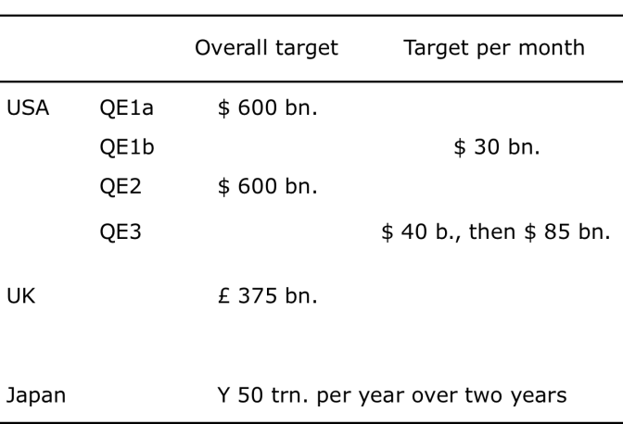
Source: Central banks.
How much can that be? The basis for the first wave of TLTRO, 7% of bank loans outstanding in April 2014, is about EUR 400 billion. This is the maximum that can be injected. The basis for the second wave of LTRO is unknown because it depends on loans that will be created over the next two years. Similarly, many of the ABS and covered bonds that will be purchased have still to be created. According to the Covered Bond Council, the amounts of covered bonds outstanding in 2010 were about EUR 1.6 trillion, but we do not know yet whether existing bonds will be accepted or whether the programme will only concern new ones. Much the same should apply to ABS, but the existing stock seems much smaller as these instruments have been tainted by the crisis. The ECB has indicated that it expects to inject liquidity “in the hundreds of billions”. This means that the success of the operation depends not just on the willingness of banks to make loans and sell them, but also on the willingness of financial institutions to create ABS and covered bonds.
On the other hand, if liquidity indeed increases in very large amounts, the programmes may help the Eurozone recover growth. A key reason, noted above, is that the exchange rate of the euro should decline, possibly quite significantly, thus boosting external competitiveness. The importance of this channel cannot be exaggerated, although the ECB will not want to elaborate on this ‘beggar-thy-neighbour’ aspect.

CONCLUSION
Having missed its inflation target, the ECB had really no choice but to act. The interest rate decision has been mostly symbolic since the zero lower bound has been reached. The important decisions are those that create a Eurozone-style QE programme. Given the situation, it was just a matter of time until the ECB would decide to follow other major central banks. Probably, it has been held by non-economic considerations. The same considerations may also have shaped the programme.
What are these non-economic considerations? The first one is the deeply misguided view that rapid increases in liquidity must always lead to high inflation rates. While this is a good rule under normal circumstances, it can be highly misleading in crisis conditions. In normal times, commercial banks use their liquidity to grant loans, which feeds demand and ultimately inflation. In the current conditions, the traditional link is broken as banks do not grant loans and rather hoard liquidity. Indeed, the central banks are trying to discourage hoarding – including with negative interest rates – and to encourage bank lending.
The second consideration, influenced by the first one, is that some non-crisis countries do not want the ECB to take risks. They do not wish to have to finance the crisis countries. In some cases, they see the poor growth environment as an encouragement to undertake long-delayed structural reforms. However, outside mandatory IMF-style programs, there is no evidence that poor economic conditions encourage serious reforms.
The third consideration, also influenced by the first one, is that QE involves indirect financing of deficits and debts. Indeed, large-scale QE involve massive purchases of public debt instruments. There is evidence that it is indeed the case. The reason is that deficit and debt financing leads to large increases in liquidity and therefore to rapid inflation. “Therefore”, however, does not hold, as argued above.
These misconceptions influence the ECB. This is why it waited far too long to adopt its programmes. This is also it has chosen a weak form of QE. One can hope that the programmes will work, as they did in the UK and the US. Given their dependence on commercial bank behaviour, this is not guaranteed.

REFERENCES
- Baumeister, Christiane and Luca Benati (2013) “Unconventional Monetary Policy and the Great Recession: Estimating the Macroeconomic Effects of a Spread Compression at the Zero Lower Bound”, International Journal of Central Banking 10(3): 165-212.
- Christensen, Jens H. E. and Glenn D. Rudebusch (2012) “The Response of Interest Rates to US and UK Quantitative Easing”, The Economic Journal 122(564): F385–F414.
- Kapetanios, George, Haroon Mumtaz, Ibrahim Stevens and Konstantinos Theodoridis (2012) “Assessing the Economy-wide Effects of Quantitative Easing”, The Economic Journal 122(564): F316-F347.
- Krishnamurthy, A., and A. Vissing-Jorgensen (2011) “The Effects of Quantitative Easing on Interest Rates: Channels and Policy Implications”, Brookings Papers on Economic Activity 2: 215–65.
- Wyplosz, Charles (2011) “Changing of the Guards at the ECB”, Briefing Note to the Committee for Economic and Monetary Affairs, European Parliament.

EONIA (Euro OverNight Index Average) is an effective overnight interest rate computed as a weighted average of all overnight unsecured lending transactions in the interbank market in Euros.
Outright Monetary Transactions (OMT) is a program of the European Central Bank under which the bank makes purchases (outright transactions) in secondary, sovereign bond markets, under certain conditions, of bonds issued by Eurozone member-states.
The first country to use macro-prudential measures to curb a potential bubble is Switzerland. Early observation is that it is working.
Details on the programme are missing at this stage.
During its previous covered bond purchase programme in 2009-10, the ECB bought EUR 60 billion.

